14/10/26
1. i am looking at the website and notice somethings we can improve. For instance when i open the first page where it asks what is your current situation, there are only 6 situations. there certainly can be more correct? can we add these? only if you verify they are meaningful.
2. when i choose the vaderschapsverlof for instance, the blue link "open official request page" shows me where to find all information and one of the info is contact ziekenfonds but there should be another link under the blue one with "request now" for instance, that actually takes us straight to the link of the mutuality where you effectively request it or contact the mutuality as the case maybe. Maybe you should switch the current "open official request page" to "all information" and the second link that takes you to the actual request page as the "request now" tab. Do you understand what I mean? please repeat before execution so i know for sure you understood what i meant.
use google search as a guide..if you want an official government website with the correct info here, if you want to request it now, here is the link that takes you straight to requesting it no more bla bla..

22/10/26
3. I selected that I am a student and CM as my mutuality. Why does it also show zwangerschap benefits too? please it should only show student benefits and CM student benefit NO pregnancy except the person choose pregnancy and student too as situation.
4. How can these be interesting for international students coming to study in belgium?
5. When do you think the toevoegen tab should be opened to the public to add benefits while we approve? Currently we are still brainstorming with friends who work in ocmw and other sectors for feedback..How will i get a notification that someone submitted an idea/benefit? how do i approve?

23/10/26
6. that tab in the beginning shows the combination one viewed last..i viewed Brugelette last search; instead of saying "your benefits Brugelette" let it show "your last viewed benefits Brugelette"
7. i do not like the wording "what you are owed found in one place" instead make it "tailored benefits found in one place".
8. like number 7 above, please look through the wordings of the website again and how they are framed, what we are trying to achieve is to help people find benefits they can enjoy. such strong wordings like my right, what i am owed etc should not be in our website. we do not need a cost cutting politician to hate our website.
9. what qualifys one to be entitled to the benefits in our website? being an employee? people enjoy these rights because they are "living in belgium" or "are a (permanent) resident" or "citizen" as the case maybe. maybe a good idea to differentiate these categories on the intro "get started" tab so people do not waste their time thinking they are entitled. ex i was once an international student and i do not think i benefit from a lot of these. so allow ticking resident status "student", "employee" etc whether a "citizen" or "resident"perhaps to select country of citizenship? I say this because a German citizen who now lives in Belgium and an employee can benefit too..I allow you to make the correct category or categories to click.
10. the "submit" button, change it to "add a benefit".
11. suggest 5 logos for us to choose from. this should also be in the websites and other things we will begin to do later like social media..already add what we will choose in the website.
12. Folow the example of this website https://waarwonen.be/over-ons/ to make an about us in the website.
13. I was looking at someones website, please see that this screenshot never appears as someone wants to open our website. Please NOTHING of unsafe. Thanks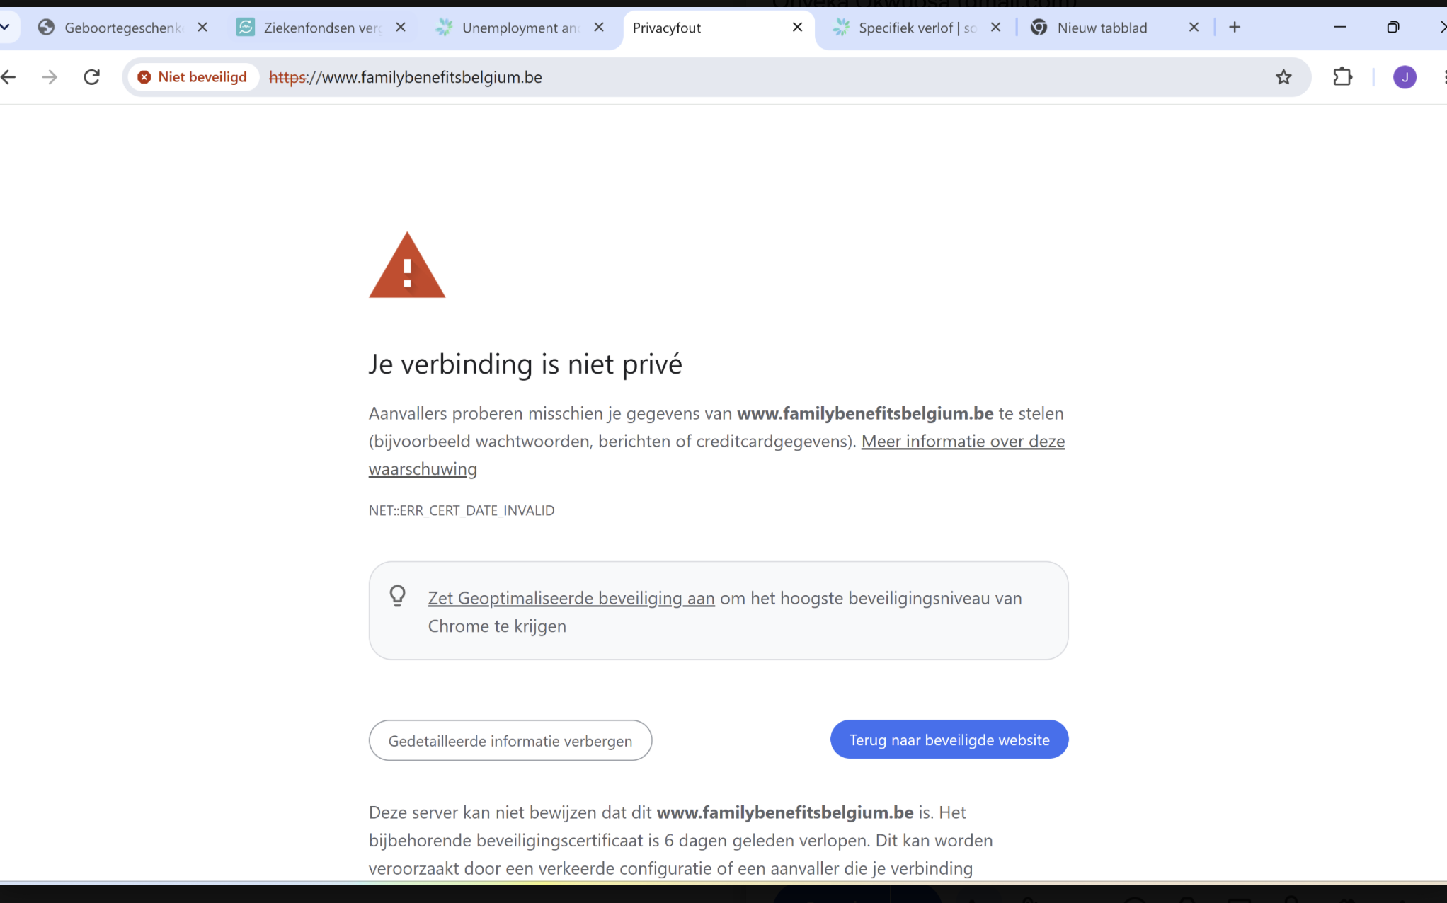

14.

